Pi: Cube

A LED cube shield for Raspberry Pi

Pi: Cube is a 4x4x4 LED shield for the Raspberry Pi. It can be used by beginners and professionals to strengthen their logic by typing complex code to draw out various patterns among its various uses.

**Features:**

1. 64 high intensity monochromatic LEDs
2. GPIO based operation
3. 40-pin stacking header for accessing GPIO of RPIs
4. Each Layer as well as each LED can be individually accessed and controlled as per requirements

**Overview:**

* This is how the LED Cube looks like

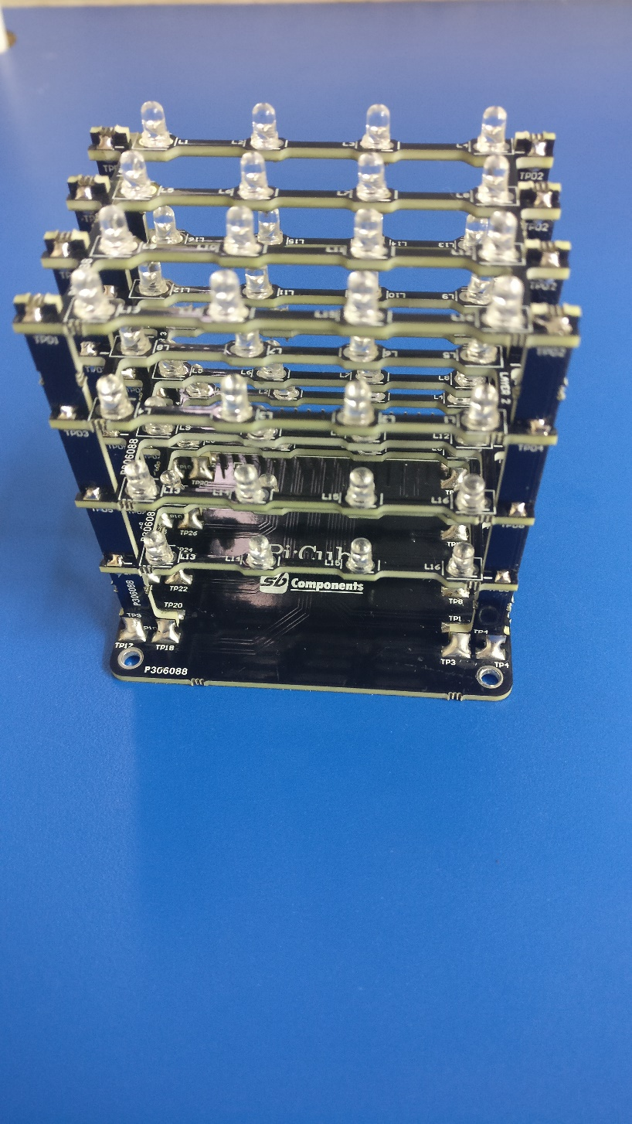

* 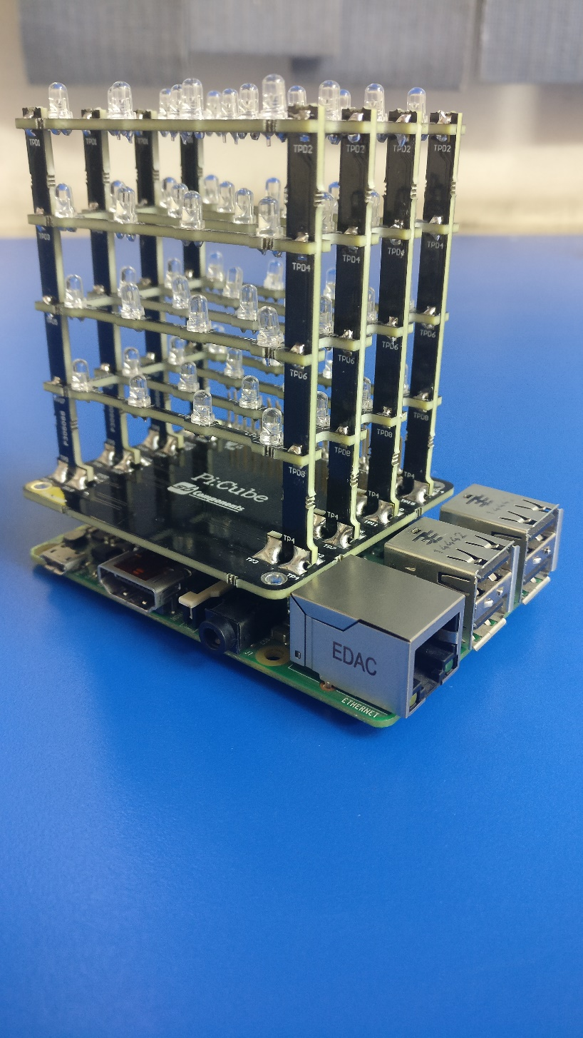Cube on the Raspberry Pi
* Diagram of a single layer of PI: Cube

GPIO PIN

How to control 64 LEDs without using 64 individual wires? Multiplexing!

Running a wire to the anode of each led would obviously be impractical, and would look really bad.One way to get around this, is to split the cube into 4 layers of 16x16 LEDs.

All the LEDs aligned in a vertical column share a common anode (+).

All the LEDs on a horizontal layer share a common cathode (-).

**LED and Layer Pin Evaluation:**

|  |  |
| --- | --- |
| PIN number | Layer |
| 40 | **Layer1(Top)** |
| 38 | **Layer2** |
| 36 | **Layer3** |
| 32 | **Layer4(Bottom)** |

|  |  |  |  |
| --- | --- | --- | --- |
| GPIO PIN number | | | |
| 7(L1) | **11(L2)** | **35(L3)** | **37(L4)** |
| 12(L5) | **13(L6)** | **31(L7)** | **33(L8)** |
| 15(L9) | **16(L10)** | **23(L11)** | **29(L12)** |
| 18(L13) | **19(L14)** | **21(L15)** | **22(L16)** |

**NOTE: The pin numbers are specified using the BOARD configuration of the GPIO pins**

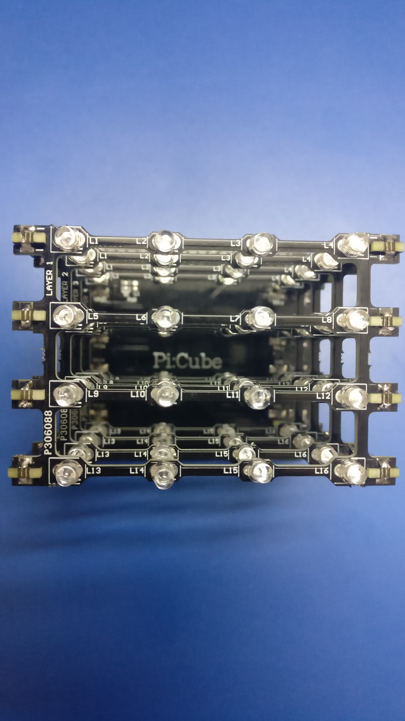

Layers and LEDs marked for ease.